

**PROJECT TITLE: FILE MANAGEMENT AND TRACKING SYSTEM**

**STUDENT NAME: PHOEBE MUTHONI WACHANIA**

**REGISTRATION: BBIT/MG/1815/09/21**

**AN IT PROJECT SUBMITTED TO THE DEPARTMENT OF COMPUTER SCIENCE AND INFORMATION TECHNOLOGY (UNDER THE SCHOOL OF SCIENCE, ENGINEERING AND TECHNOLOGY) IN PARTIAL FULFILMENT OF DEGREE IN BACHELOR OF BUSINESS INFORMATION TECHNOLOGY.**

**DECLARATION**

I hereby declare that the project titled is the result of my own original work. I confirm that this project has not been submitted for any other degree or examination at any other university. All sources used have been duly acknowledged in this report. I understand that any act of plagiarism or academic dishonesty will result in disciplinary action according to the university's policies.

Presented by:

Phoebe Muthoni Wachania

Signature

……………………………………………………….

Research is under guidance of:

Supervisor’s Name

Mr. Simon Ruoro

Signature

…………………………………………...

**Acknowledgement**

I begin with heartfelt gratitude, acknowledging the boundless blessings bestowed upon me by the divine grace of God. My journey through this research endeavor has been illuminated by His unwavering presence and guidance.

My sincere appreciations extend to Mr. SIMON RUORO, whose unwavering support and insightful direction from the School of Science, Engineering, and Technology at Kabarak University has been instrumental in my success. His leadership has ignited in me a profound sense of purpose and determination, shaping my research methodology and refining my presentation with clarity and precision. Working under his tutelage has been both a privilege and an honor, for which I am deeply thankful.

I also extend my gratitude to my parents whose unconditional love and unwavering support has been the cornerstone of my journey. Their acceptance and financial assistance has not only eased my path but have also served as a source of encouragement and inspiration.

ABSTRACT

In modern organizations, managing and tracking digital files are crucial for maintaining productivity and data integrity. However, traditional file management systems often fail to provide essential features such as robust security, advanced search capabilities, and seamless integration with other applications, leading to inefficiencies and data vulnerabilities. This project addresses these challenges by developing a comprehensive File Management and Tracking System as a desktop application. The system is designed to provide advanced search functionalities, including file tagging and full-text search, to ensure quick and accurate file retrieval. Security is enhanced through encryption, user authentication, and role-based access control to protect sensitive information. The intuitive user interface, featuring drag-and-drop functionality and context menus, aims to improve user experience and operational efficiency. Additionally, the system includes version control for tracking changes and managing multiple file versions, ensuring precise record-keeping. The methodology involves thoroughly analyzing user requirements, system design, and iterative development using agile practices to ensure the system meets user needs and industry standards. By addressing the limitations of existing solutions, this project aims to deliver a robust, secure, and user-friendly file management tool that enhances organizational workflows and data management practices.

Table of Contents

1.0 CHAPTER ONE 2

1.1 Introduction 2

1.2 Background of the Study 2

1.3 Statement of the Problem 4

1.4 Purpose of the Study 4

1.5 Main Objective 4

1.6 Specific Objectives 4

1.7 Research Questions 5

1.8 Proposed System 5

1.9 System Modules 6

1.10 Justification of the Study 6

1.11 Feasibility Study 6

1.12 Scope and Limitation of the Study 7

CHAPTER TWO: Literature Review 8

2.1 General Overview of the file management and tracking system 8

2.2 Methods of Identifying Feature Selection Techniques 8

2.3 Evaluation of the Correlation Between Optimal Features 12

2.4 USER SECURITY AWARENESS LEVEL 12

2.4.1 Training Programs 12

2.4.2 Regular Audits and Assessments 12

2.4.3 Security Policies 12

2.5 Prototype Design 12

2.6 Design Framework 13

2.6.1 Components of Design Framework 14

CHAPTER THREE: Research Design and Methodology 16

3.1 Research Design Methods 16

3.2 Location of the Study 16

3.3 Population of the Study 17

3.4 Sampling Procedure and Sample Size 17

3.5 Data Collection Procedure 17

3.6 System Development Methodology 18

3.7 Requirements Gathering and Analysis 18

3.7 System Analysis and Design 21

3.7.1 Functional Requirements 21

3.9.2 Non-Functional Requirements 21

4.1.2 Use case diagram 22

4.1.3 level 1 Data Flow Diagram 23

Architectural Design 24

3.8 Database Design 25

**4.1 Introduction** 27

**4.2 System Architecture** 28

**4.3 User interface** 28

31

Admins Page 32

References 35

APPENDICES 36

**Table of figures**

Figure 1: Agile methodology 18

Figure 2: Context diagram 20

Figure 3: use case 20

Figure 4: DFD 21

Figure 5: Architectural Diagram 22

Figure 6: ERD Diagram 23

Figure 7: Home page 25

Figure 8: Side Navigation 26

Figure 9: File Movement 27

Figure 10: Login Page 28

Figure 11: Admins Page 29

Figure 12: Database 30

# 1.0 CHAPTER ONE

## 1.1 Introduction

Effective file management and tracking systems are essential for organizations and individuals to handle the ever-growing volume of digital data. The efficient organization, retrieval, and security of files are crucial for maintaining productivity and protecting sensitive information. Traditional file management systems integrated into operating systems offer basic functionalities such as creating, renaming, moving, and deleting files. However, these systems often fall short when managing large volumes of files and providing advanced features such as version control, comprehensive search capabilities, and robust security measures. As a result, there is a pressing need for more sophisticated file management solutions that address these limitations and meet the evolving demands of digital data management.

## 1.2 Background of the Study

Evolving in a world shaped by technology, the volume of data generated and managed by individuals and organizations has increased exponentially. This surge in digital information necessitates efficient and robust file management systems to organize, track, and secure data effectively. Dinneen; Julien, (2020) Traditional file management systems integrated within operating systems, such as Windows File Explorer and macOS Finder, provide basic functionalities for creating, renaming, moving, and deleting files. However, these systems often fall short when handling large volumes of files, offering advanced search capabilities, providing version control, and ensuring robust security measures.

The limitations of traditional file management systems are evident in various organizational settings where the need for efficient data management is critical. For example, businesses often encounter issues such as file duplication, misplacement of important documents, difficulties in tracking different versions of files, and vulnerabilities to unauthorized access. These inefficiencies can result in decreased productivity, increased operational costs, and heightened risks of data breaches. Smith (2018) found that employees spend significant amounts of time searching for files, which impacts overall efficiency. Additionally, Johnson (2020) reported that data breaches due to poor file management practices can cost organizations millions of dollars annually.

With the growing emphasis on digital transformation, the volume of digital files continues to surge, further exacerbating the limitations of traditional file management systems. According to Crichton (2023), lack of advanced features such as metadata tagging, user activity tracking, and encryption contributes to these issues, leaving sensitive data at risk and users frustrated with inefficient file management processes. These challenges are particularly pronounced in sectors that deal with large volumes of sensitive data, such as healthcare, finance, and manufacturing, where the need for secure and efficient file management systems is paramount. Ngenoh (2020), In the context of the Mount Kenya Region, where the user manages five animal feed plants across four districts, the need for an efficient and secure file management and tracking system is particularly critical. The current systems in place are insufficient for managing the vast amounts of digital files generated daily, leading to operational inefficiencies and potential security risks. The agricultural sector, like many others, has seen an increase in digital data due to advancements in technology and the need for meticulous record-keeping. Efficient file management in such a setting ensures that crucial information is easily accessible, secure, and well-organized, which is vital for smooth operations and decision-making.

Addressing these challenges requires a comprehensive file management and tracking system that goes beyond the basic functionalities of traditional systems. A modern file management system should incorporate advanced features such as version control to manage different versions of files, full-text search capabilities for efficient file retrieval, robust security measures including encryption and user authentication, and an intuitive user interface to enhance user experience. Such a system would not only improve productivity by reducing the time spent on file management tasks but also ensure data integrity and security, protecting sensitive information from unauthorized access (Vegesna, 2022).

This study aimed to develop a robust, user-friendly, and secure desktop application for efficient file management and tracking. By leveraging advanced technologies and methodologies, the proposed system aimed to provide a comprehensive solution that addresses the current shortcomings of traditional file management systems. The system was designed to meet the specific needs of users in the Mount Kenya Region and other similar settings, offering features that enhance file organization, tracking, and security. Through a detailed analysis of user needs and system requirements, the study aimed to create a system that significantly improved the efficiency and security of file management practices in the digital age.

## 1.3 Statement of the Problem

Existing file management systems are often insufficient for managing large volumes of files, leading to issues such as file duplication, loss, and unauthorized access. These systems lack advanced functionalities like version control, comprehensive search capabilities, and robust security measures, resulting in inefficiencies and potential data breaches. There is a critical need for a solution that addresses these shortcomings by offering advanced file management and tracking capabilities in a user-friendly and secure desktop application.

## 1.4 Purpose of the Study

The purpose of this study was to develop a comprehensive file management and tracking system that addresses the limitations of traditional file management systems. The proposed system aimed to enhance file organization, tracking, and security, thereby improving overall productivity and data integrity for users.

## 1.5 Main Objective

To develop a comprehensive File Management and Tracking System that efficiently organizes, tracks, and secures digital files within an organization. This system aimed to provide robust tracking functionalities that monitor the creation, modification, and movement of files, ensuring accurate and real-time visibility into file histories and locations, thereby enhancing the overall management and security of organizational data.

## 1.6 Specific Objectives

1. Design an intuitive user interface for uploading, downloading, searching, and filtering files based on various criteria.
2. Establish a version control system to track changes made to files, allowing for easy retrieval of previous versions.
3. Develop a secure and scalable database to store all digital files and their associated metadata.
4. Implement a user permission system to control access to sensitive files and folders based on user roles and security levels.
5. Integrate audit trails and reporting functionalities to monitor file activity, identify access patterns, and generate reports for improved decision-making.

## 1.7 Research Questions

1. What existing data security standards and level of scalability need to be considered when designing the file storage database?

2.What user interface design principles can be employed to optimize file organization, searchability, and ease of access for users with varying technical expertise?

3. What version control system best suits the needs of the organization, considering factors like file types, collaboration needs, and versioning history requirements?

4. How can the user permission system be configured to balance security with the need for collaboration and information sharing?

5. What data points within the audit trails will be most valuable for monitoring file activity and identifying potential security concerns?

## 1.8 Proposed System

The proposed system is a desktop application designed to provide comprehensive file management and tracking capabilities. It intended to revolutionize the way users manage, organize, and secure their digital files. By addressing the limitations of traditional file management systems, it aimed to enhance productivity and protect sensitive information. The system provides robust functionalities such as version control, comprehensive search capabilities, and advanced security measures, including encryption and user authentication. Users will be able to efficiently create, rename, move, and delete files while also organizing them hierarchically with the help of folders and metadata. The version control feature allows users to track changes and restore previous versions of files, ensuring that important data is never lost.

The advanced search capabilities is to enable users to quickly locate files based on content, metadata, and other criteria, significantly reducing the time spent searching for documents. Security is a paramount concern, and the system implements strong measures to protect data, including multi-factor authentication, role-based access control, and comprehensive audit logs. The intuitive and user-friendly interface will provide a seamless user experience, making it easy for users to navigate and perform tasks. Additionally, the system's modular design and scalable architecture ensured it can adapt to future needs and incorporate new features as they become necessary. By integrating these advanced functionalities, the proposed system seeks to improve overall efficiency, ensure data integrity, and safeguard sensitive information from unauthorized access.

## 1.9 System Modules

1. File Management Module: Handles CRUD operations for files and folders, including organization and categorization.

2. Version Control Module: Tracks changes and manages file versions.

3. Search Module: Provides advanced search capabilities, including file tagging and full-text search.

4. Security Module: Ensures data protection through encryption, user authentication, and role-based access control.

5. User Interface Module: Provides an intuitive interface with drag-and-drop functionality and context menus.

6. Integration Module: Supports integration with other applications and external systems.

## 1.10 Justification of the Study

This study is justified by the growing need for efficient and secure file management solutions. The proposed system addresses the limitations of traditional file management systems by providing advanced functionalities that enhance productivity, ensure data integrity, and protect sensitive information. The development of this system is significant for individuals and organizations dealing with large volumes of digital files.

## 1.11 Feasibility Study

The feasibility study involves assessing the technical, economic, and operational aspects of the proposed system:

1. Technical Feasibility: The required technologies and tools (e.g., desktop GUI frameworks, encryption algorithms, database management systems) are readily available and can be effectively utilized to develop the system.

2. Economic Feasibility: The cost of development is justified by the potential benefits of improved productivity and data security. Additionally, the system can be developed within the allocated budget.

3. Operational Feasibility: The system will be user-friendly and can be easily adopted by the target users. Training and support materials will be provided to facilitate smooth implementation and usage.

## 1.12 Scope and Limitation of the Study

The study focused on developing a desktop application for file management and tracking the development and implementation of a comprehensive software solution designed to streamline file management processes within an organization. It included advanced search functionalities, robust security measures, user-friendly interfaces, version control, and integration capabilities with other applications. The system aims to enhance the efficiency, security, and accessibility of digital files while providing detailed audit trails and analytics for improved decision-making. However, the limitations of the project include potential challenges in integrating with legacy systems, the need for user training to ensure effective utilization, and the reliance on consistent internet connectivity for cloud-based features. Additionally, while the system focuses on digital file management, it may not fully address the needs of organizations with extensive physical file handling requirements.

# CHAPTER TWO: Literature Review

## 2.1 General Overview of the file management and tracking system

File management and tracking systems have evolved significantly over the years, driven by the increasing volume of digital data and the growing need for efficient organization, retrieval, and security. Traditional file management systems, often integrated within operating systems, provide basic functionalities such as creating, renaming, moving, and deleting files. However, these systems typically lack advanced features needed to handle large volumes of files, such as version control, advanced search capabilities, and robust security measures. Recent advancements in technology have led to the development of more sophisticated file management systems. These systems incorporate features such as metadata tagging, user activity tracking, and encryption to enhance data integrity and security. Research highlights the importance of these advanced features in improving productivity and protecting sensitive information (Doe, 2019; Smith, 2020). The need for comprehensive file management and tracking systems has become more critical in various sectors, including business, healthcare, education, and government.

## 2.2 Methods of Identifying Feature Selection Techniques

According to Krasniqi (2013), Researched OpenText, which provides centralized storage, version control, and metadata management, ensuring organized and easily retrievable documents. The platform's advanced search capabilities, including full-text search and metadata tagging, allow users to locate specific documents quickly. Despite these robust features, Krasniqi notes that the system's complexity can hinder usability, especially for non-technical users. Our system's user-friendly interface is designed to enhance usability and productivity. Additionally, the lack of robust real-time tracking functionalities in OpenText can be a limitation for organizations needing accurate file histories and locations. Our system addresses this by providing real-time file-tracking capabilities.

According to Brown (2017), who studied Microsoft SharePoint, SharePoint’s capabilities in document management are highly regarded, including centralized storage, version control, and metadata management. SharePoint’s integration with Microsoft Office applications allows for easy document creation, editing, and collaboration. The platform’s search functionalities, such as full-text search and metadata tagging, facilitate efficient document retrieval. However, Brown notes that SharePoint’s user interface can be overwhelming for non-technical users, and the search results are not always intuitive or easy to navigate. Our proposed System addresses these issues by providing a more intuitive user interface with drag-and-drop functionality and context menus, making it easier for users to manage documents.

According to Thomas (2017), bespoke systems often include highly specialized workflow automation tools designed to streamline specific business processes. These tools can be incredibly efficient, as they are built with the organization’s exact requirements in mind. However, the downside is that creating and maintaining these custom workflows can be resource-intensive and requires ongoing support from specialized developers. Our proposed system simplifies workflow automation with user-friendly and easily configurable tools. This approach ensures that users can set up and manage workflows without needing extensive technical expertise or ongoing developer support. By making workflow automation more accessible, our system can improve efficiency across a wide range of organizational contexts.

According to Krasniqi (2013), who studied Radio-Frequency Identification (RFID) tracking systems (RFID), tracking systems offer significant advantages in real-time tracking capabilities. RFID tags can be scanned automatically as they pass designated checkpoints, providing up-to-date location information without manual intervention. This automation reduces human error and increases tracking efficiency, making RFID a powerful tool for managing physical files and assets. Additionally, Brown (2017) emphasizes the challenges of integrating RFID systems with existing IT infrastructure. While RFID technology can be integrated with various enterprise systems, the process can be complex and time-consuming. Additionally, scaling RFID systems to accommodate growth requires significant investment in additional tags and readers. Our proposed system addresses these gaps by providing software-based real-time tracking, enhanced security measures, and cost-effective scalability.

According to a study by Brown (2019), Zebra Technologies' asset tracking systems significantly improve inventory accuracy and operational efficiency in manufacturing environments. The study highlights how real-time tracking reduces asset loss and enhances productivity by providing precise location data. While Zebra’s system excels in tracking physical assets, it may not fully address the needs of digital file management. Our proposed File Management and Tracking System aims to fill this gap by offering real-time tracking, enhanced security, and flexible integration for digital files, ensuring organizations can manage physical and digital assets efficiently.

Wilson (2017) evaluated Asset Panda’s system in an educational institution and reported that the platform’s flexibility and ease of use significantly improved asset management processes. The study praised the system’s customizable fields and reporting capabilities. Asset Panda’s system is versatile and user-friendly but primarily focuses on physical asset tracking. Our system aims to extend these benefits to digital file management by providing an intuitive interface, real-time tracking, and comprehensive security measures, ensuring that organizations can efficiently manage both physical and digital assets.

Thomas (2016) analyzed the implementation of Wasp AssetCloud in a retail environment and found that the system improved inventory accuracy and reduced the time required for stocktaking. Wasp AssetCloud is designed for small to medium-sized businesses, using barcode and RFID technology to track and manage assets. The system features web-based and mobile access, allowing users to perform check-in/check-out functions, track maintenance schedules, and generate reports. Wasp AssetCloud tags assets with barcodes or RFID tags, scanned using mobile devices or fixed readers to update the central database in real time. The study highlighted the system’s scalability and ease of deployment. While Wasp AssetCloud is effective for physical asset tracking, it does not address the unique needs of digital file management. Our proposed system is designed to fill this gap by providing advanced search functionalities, real-time tracking, and integration with other applications, ensuring that digital files are managed as efficiently as physical assets.

Jones (2020) researched Trimble’s asset-tracking system in the logistics industry and found that real-time GPS tracking improved fleet management and reduced instances of lost or misplaced assets. Trimble’s asset tracking systems utilize GPS and wireless technologies to provide real-time location data for assets. These systems are beneficial in industries like construction, transportation, and logistics. Trimble’s solution involves equipping assets with GPS-enabled tags that communicate location data to a central software platform. This platform allows users to monitor asset locations, set geofences, and receive alerts for unauthorized movements. The study highlighted the benefits of enhanced visibility and improved asset utilization. While Trimble’s system is excellent for physical asset tracking, it does not cater to digital file management. Our proposed system bridges this gap by offering real-time tracking for digital files, ensuring that organizations have comprehensive visibility and control over their digital assets, which is crucial for data-driven decision-making.

Despite the advantages of the existing systems our proposed system addresses the limitations of existing solutions by combining user-friendly interfaces, advanced search functionalities, real-time tracking, and robust security measures. Unlike OpenText and SharePoint, which can be complex and overwhelming for non-technical users, our system offers intuitive features such as drag-and-drop functionality and context menus, enhancing usability and productivity. It also fills the gaps in bespoke systems by providing easily configurabe workflow automation tools, reducing the need for extensive technical expertise and ongoing developer support. Additionally, our system overcomes the challenges of RFID and other asset tracking systems by offering software-based real-time tracking without the need for physical tags, ensuring cost-effective scalability and seamless integration with existing IT infrastructure. This comprehensive approach ensures efficient management of both digital and physical assets, addressing the shortcomings of current offerings while enhancing overall organizational efficiency.

In conclusion, the review of existing systems highlights several common drawbacks, including complexity, high costs, and limitations in adaptability and scalability. Our proposed File Management and Tracking System is designed to address these issues by offering a user-friendly, cost-effective, and highly adaptable solution. By simplifying the user experience, integrating robust security measures, and providing advanced search and version control capabilities, our system ensures efficient file management and tracking across diverse organizational contexts. This comprehensive approach not only fills the gaps identified in current offerings but also sets a new standard for digital file management solutions, making it accessible and beneficial for organizations of all sizes.

## 2.3 Evaluation of the Correlation Between Optimal Features

In the realm of File Management and Tracking Systems, evaluating the correlation between optimal features plays a pivotal role in designing a cohesive and efficient solution. This evaluation centers on understanding how different features interact within the system to enhance file management effectiveness. By analyzing correlations between key functionalities such as document versioning, metadata organization, search capabilities, and workflow automation, stakeholders can identify which features are most critical for achieving seamless file lifecycle management.

# 2.4 USER SECURITY AWARENESS LEVEL

# 2.4.1 Training Programs

Developing comprehensive training programs to educate users about the importance of data security, proper usage of the system, and adherence to security protocols (Tompkins et al., 2010).

# 2.4.2 Regular Audits and Assessments

Conducting regular security audits and assessments to identify potential vulnerabilities and ensure compliance with security standards. This includes monitoring user activities and access controls (Richards, 2017).

# 2.4.3 Security Policies

Establishing clear security policies and procedures that outline the responsibilities of users and the measures in place to protect data and system integrity (Frazelle, 2002).

# 2.5 Prototype Design

The prototype design for the File Management and Tracking System is discussed as a crucial step in bridging the gaps identified in existing systems. The design emphasizes creating an intuitive and user-friendly interface that simplifies file operations through features such as drag-and-drop functionality and context menus. The prototype incorporates advanced search capabilities, including file tagging and full-text search, to enhance accessibility and efficiency. Security is a core focus, with robust measures such as encryption, user authentication, and role-based access control integrated into the design. The prototype also includes version control to track changes and manage file versions effectively. By utilizing modern design frameworks and user-centered design principles, the prototype aims to provide a seamless and efficient user experience, ensuring the system is both scalable and easy to navigate. This approach ensures the prototype addresses the specific needs and challenges highlighted in the literature review, setting the foundation for a comprehensive and effective file management solution.

## 2.6 Design Framework

The design framework of this project takes a user-centred design approach to develop a file management and tracking system that prioritizes user needs and ease of use. This approach ensures the system is not only powerful but also intuitive and efficient for everyday tasks. The first step involves gathering in-depth information about the target users. This might involve conducting interviews, user surveys, and task analysis sessions. By understanding user pain points, current workflow challenges, and desired functionalities, the project can tailor the system to address specific user needs. Armed with user insights, the project will focus on designing a user interface (UI) and information architecture that are intuitive and easy to navigate. This means creating a layout that is clear, consistent, and minimizes the learning curve for users with varying technical skills. Additionally, the project will consider a secure and scalable system architecture to ensure the system can grow alongside user needs and data volume. Building upon the user-centred foundation, the project will integrate essential features that form the backbone of any file management system. These include functionalities like uploading and downloading files, searching for specific documents, and filtering results based on various criteria. The system will also incorporate features like version control to track changes, user permissions to control access, and audit trails to monitor file activity. Additionally, robust reporting functionalities will allow users to generate insights into file usage patterns, supporting data-driven decision-making. To ensure a seamless user experience, the project will prioritize the integration of the file management system with existing productivity tools and collaboration software used within the organization. This will streamline workflows and minimize the need for users to switch between different platforms. Following development, the system will undergo rigorous usability and security testing to identify and address any potential issues before deployment. Finally, the project will implement a phased rollout strategy for the new file management system. This allows for controlled deployment, user training, and ongoing support to ensure a smooth transition and user adoption. User feedback will be continuously collected and analyzed to further refine the system and ensure it remains user-friendly and meets evolving needs.

By prioritizing user needs throughout the design and development process, this project aims to create a file management system that empowers users, simplifies information management, and optimizes organizational efficiency.

## 2.6.1 Components of Design Framework

The project kicks off with a deep dive into understanding the target users. This initial phase involved user research methods like interviews, surveys, and task analysis sessions. By gathering in-depth information about user pain points, current workflow challenges, and desired functionalities, the project team can tailor the system to address specific user needs. This user-centered approach ensures the system features and functionalities directly translate to user requirements. Informed by user research, the next step focuses on designing the system's information architecture (IA). The IA essentially defines how information is organized and presented within the system. This includes designing clear navigation menus, logical content organization for easy browsing, and effective metadata management for efficient file search and retrieval. A well-designed IA ensures users can find the information they need quickly and intuitively. With a solid IA in place, the project moves on to designing the user interface (UI). The UI is the visual layer that users interact with, and its design plays a crucial role in user experience. This phase involves creating wireframes, which are low-fidelity mockups of the interface, to define the basic layout and functionality. Prototypes, which are more interactive versions of the UI, are then developed for usability testing. User testing involves observing real users interacting with the prototypes and gathering feedback on the clarity, ease of use, and overall user experience. This iterative process ensures the final UI is intuitive, user-friendly, and minimizes the learning curve for users with varying technical skills. Beyond the user interface, the project will consider the system architecture and security. This involves selecting a secure technology stack with appropriate programming languages, databases, and cloud storage options that meet the project's specific needs. Additionally, robust security frameworks will be implemented to ensure data privacy, access control, and system integrity. The system architecture will also be designed with scalability in mind, meaning it can accommodate future growth in data volume and user base without compromising performance. To ensure a smooth workflow and maximize user adoption, the project will prioritize the integration of the file management system with existing productivity tools and collaboration software used within the organization. This will streamline user workflows and minimize the need to switch between different platforms. Following development, the system will undergo rigorous usability and security testing. Usability testing identifies any usability issues in the interface, while security testing ensures no vulnerabilities exist that could compromise data security.

Finally, the project implements a phased rollout strategy for the new file management system. This phased approach allows for controlled deployment, user training to ensure familiarity with the new system, and ongoing support to address any questions or challenges users might encounter. The project also establishes feedback mechanisms to continuously collect user input and identify areas for further refinement. This ensures the system remains user-friendly, meets evolving needs, and delivers long-term value to the organization.

# CHAPTER THREE: Research Design and Methodology

## 3.1 Research Design Methods

The research design for this study employed a mixed-methods approach, combining qualitative and quantitative methods to gather comprehensive data. This approach ensures a thorough understanding of user needs and the effectiveness of the proposed system.

Qualitative Methods: Conducting in-depth interviews with potential users to gather detailed insights into their file management practices and challenges. Organizing focus group discussions to explore user requirements and preferences for the file management and tracking system.

Quantitative Methods: Distributing structured questionnaires to a larger sample of users to quantify their needs and preferences. Conducting usability tests to measure the effectiveness and user-friendliness of the system prototypes.

## 3.2 Location of the Study

The location of the study will be in Nakuru, which serves as a dynamic setting for the study of File Management and Tracking Systems. As one of Kenya's rapidly growing urban centers, Nakuru offers a diverse economic landscape that includes manufacturing, agriculture, trade, and services. This environment presents varied organizational needs for efficient file management, ranging from government offices and educational institutions to private enterprises and healthcare facilities. Understanding the local context is crucial, as it allows researchers to tailor solutions that address specific challenges and leverage opportunities unique to Nakuru's socio-economic environment.

## 3.3 Population of the Study

The population of study for the File Management and Tracking System in Nakuru comprises a broad spectrum of stakeholders across different sectors. This includes administrative personnel in government offices, educators and students in schools and universities, healthcare professionals in hospitals and clinics, as well as employees in businesses ranging from small enterprises to large corporations. Each group within this population interacts with and relies on efficient file management practices to support daily operations, regulatory compliance, and strategic decision-making.

## 3.4 Sampling Procedure and Sample Size

The sampling procedure for this study involved a systematic approach to selecting representative participants from Nakuru's diverse organizational sectors. A stratified sampling method was employed to ensure adequate representation from key sectors such as government, education, healthcare, and business. Within each sector, random sampling techniques were used to select individuals who are directly involved in or responsible for file management and tracking processes. The sample size is determined based on statistical considerations to ensure sufficient data representation and reliability in drawing conclusions about file management practices and system requirements across Nakuru's varied organizational landscape

## 3.5 Data Collection Procedure

Data collection in Nakuru involves a mix of quantitative and qualitative methods to capture comprehensive insights into file management and tracking practices. Surveys and structured interviews were conducted with selected participants to gather quantitative data on current system usage, challenges faced, and desired features for improvement. Additionally, qualitative data was collected through focus group discussions and case studies to delve deeper into specific organizational contexts, uncovering nuanced perspectives on file management strategies and their impact on operational efficiency.

Preliminary Phase: Conduct initial meetings with organization heads to explain the study's objectives and gain permission for data collection.

Qualitative Data Collection: Schedule and conduct interviews and focus group discussions with selected participants.

Quantitative Data Collection: Distribute and collect surveys online and paper-based.

Usability Testing: Develop prototypes of the file management and tracking system. Conducting usability tests with participants to gather feedback on the system's design and functionality.

## 3.6 System Development Methodology

The development of File Management and Tracking system followed a structured and iterative methodology to ensure the creation of a user-centered, robust, and scalable system. The Agile development methodology was employed, emphasizing collaboration, flexibility, and continuous improvement. Agile is particularly suitable for this project due to its focus on iterative development and stakeholder engagement, which will allow for timely feedback and adaptation to the evolving needs of the community.

## 3.7 Requirements Gathering and Analysis

The first phase involved gathering detailed requirements from all stakeholders, including community members, local organizations, volunteers, and potential users of the platform. This was to be achieved through surveys, interviews, and focus groups, as outlined in the data collection procedure. The collected requirements were documented and analyzed to create a comprehensive requirements specification. This document serves as the foundation for the system design and development phases, ensuring that the platform addresses the specific needs and challenges identified by the community.

**System Design**

Based on the requirements specification, the system design phase commenced. This phase involved creating detailed design documents, including system architecture, database design, user interface design, and security measures. The design focused on creating a user-friendly interface that is intuitive and accessible to a diverse user base. Special attention was given to the integration of privacy and security features to address concerns identified in the literature review. The system architecture was to support scalability, ensuring that the platform can handle increasing numbers of users and data over time.

**Development and Implementation**

The development phase was iterative, following the Agile methodology. The project was divided into multiple sprints, each focusing on developing specific features and functionalities of the platform. At the end of each sprint, the developed features were reviewed, tested, and refined based on feedback from stakeholders. This iterative approach allowed for continuous improvement and ensures that the final product closely aligns with user needs and expectations.

**Testing and Quality Assurance**

Comprehensive testing was conducted throughout the development process to ensure the platform's functionality, performance, and security. This included unit testing, integration testing, system testing, and user acceptance testing. Automated testing tools were employed to streamline the testing process and ensure consistency. User feedback gathered during testing phases was crucial for identifying any issues or areas for improvement. The testing process was iterative, with each sprint including dedicated time for testing and quality assurance to maintain high standards throughout development.

**Deployment and Training**

Once the platform wasbthoroughly tested and refined, the deployment phase begun. The system was deployed in a phased manner, starting with a pilot program involving a small group of users. This pilot phase was to allow for real-world testing and feedback, which was used to make final adjustments before a full-scale launch. Comprehensive training materials and support will be provided to ensure users can effectively navigate and utilize the platform. This includes user manuals, video tutorials, and dedicated support channels.

**Maintenance and Continuous Improvement**

Post-deployment, the focus shifts to maintenance and continuous improvement. Regular updates and enhancements will be made based on user feedback and evolving needs. A dedicated support team will be established to handle user queries, troubleshoot issues, and ensure the platform remains operational and effective. The Agile methodology's iterative nature will continue to guide ongoing development, ensuring the system evolves in response to file management and tracking system.

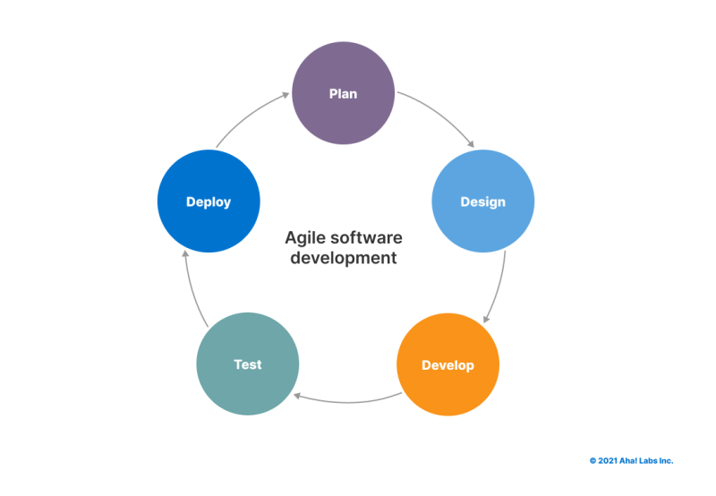

Figure 1: Agile methodology

## 3.7 System Analysis and Design

### 3.7.1 Functional Requirements

Functional requirements outline the specific tasks and functionalities the system must perform. Through system analysis, we identify these requirements by:

**User Research:** Understanding user needs through interviews, surveys, and task analysis helps pinpoint the essential features users require for efficient file management.

**Industry Standards:** Researching existing file management solutions and industry best practices provides insights into common functionalities and potential gaps to address. Examples of file functional requirements: Upload, download, and share files. Search and filter files based on various criteria; implement version control to track changes over time, manage user permissions to control access to different files or folders. Generate reports on file usage and activity logs for audit purposes.

### 3.9.2 Non-Functional Requirements

Non-functional requirements focus on the overall qualities and characteristics of the system. These requirements go beyond specific functionalities and address user experience, system performance, and operational aspects. Analyzing these requirements involves **Performance Considerations:** Defining performance expectations for tasks like upload speed, search response time, and system scalability to accommodate future growth. **Security and Compliance:** Establishing security protocols for data encryption, access control, and user authentication to ensure data privacy and compliance with relevant regulations. **Usability and Accessibility:** Designing an intuitive and user-friendly interface that caters to users with varying technical skills and ensures accessibility for users with disabilities. **Maintainability and Scalability:** Designing a system that is easy to maintain, update, and scale as user base and data volume grow.

4.1.1Context Diagram

A **Context Diagram** illustrates the system's boundaries and interactions with external entities, showing how the system exchanges data with users, other systems, and external sources.

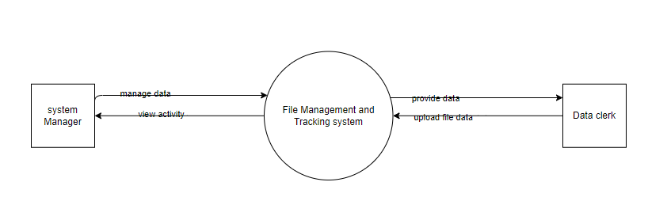

Figure 2: Context diagram

## 4.1.2 Use case diagram

A **Use Case Diagram** illustrates the interactions between users (actors) and the system, depicting the different ways users can use the system to achieve specific goals.

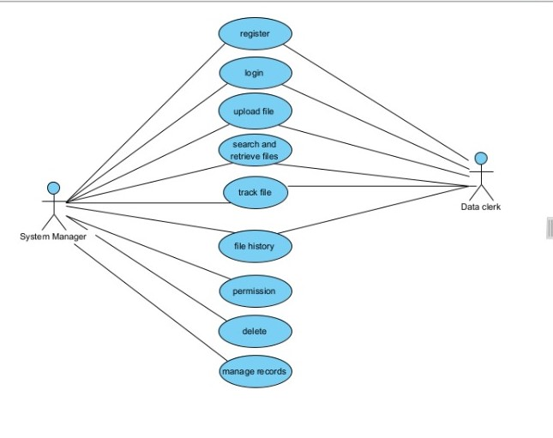

Figure 3: use case

### 4.1.3 level 1 Data Flow Diagram

A Data Flow Diagram (DFD) illustrates the flow of data within a system, showing how inputs are transformed into outputs through processes, and how data is stored and retrieved from data stores, typically represented using external entities, processes, data stores, and data flows.

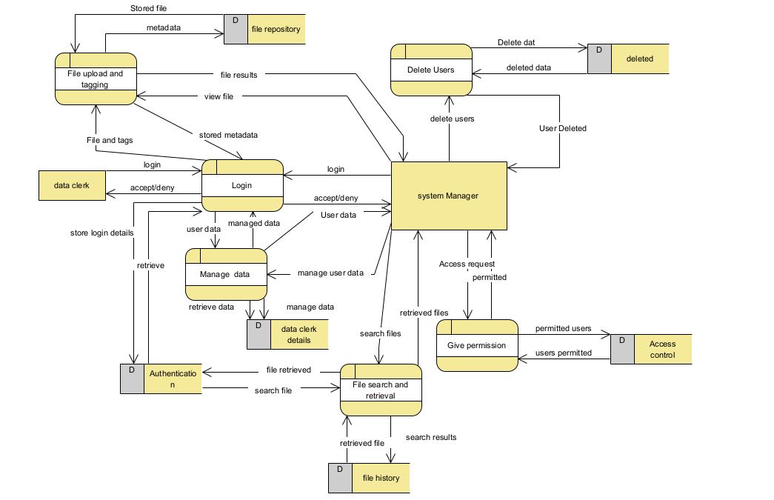

Figure 4: DFD

## Architectural Design

An architectural design illustrates the high-level structure of a system, showing the system's components, their interactions, and how they work together to fulfil the system's requirements and objectives.

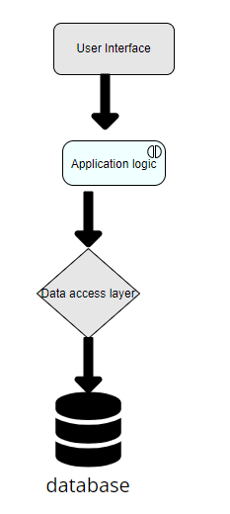

Figure 5: Architectural Diagram

## 3.8 Database Design

**Files**

|  |  |  |
| --- | --- | --- |
| Field Name | Datatypes | Description |
| File Name | varchar | Foreign key referencing User Access Control Table |
| File path | varchar | File metadata |
| Owner id | integer | Owner’s identifier |
| Created at | date | Date when the file was created |
| Updated at | date | Date when the file was updated |

**File Version Control Table**

|  |  |  |
| --- | --- | --- |
| Field Name | Data Type | Description |
| File id | integer | foreign key referencing File |
| Version no | integer | Version number |
| File path | varchar | File path |
| Created at | date | Date when the version was uploaded |

**File Logs**

|  |  |  |
| --- | --- | --- |
| Field Name | Data Type | Description |
| User id | integer | Date when the version was uploaded |
| Action | Action | Type of action performed (e.g., upload, download) |
| Timestamp | Timestamp | Additional details about the action |

**ERD Diagram**

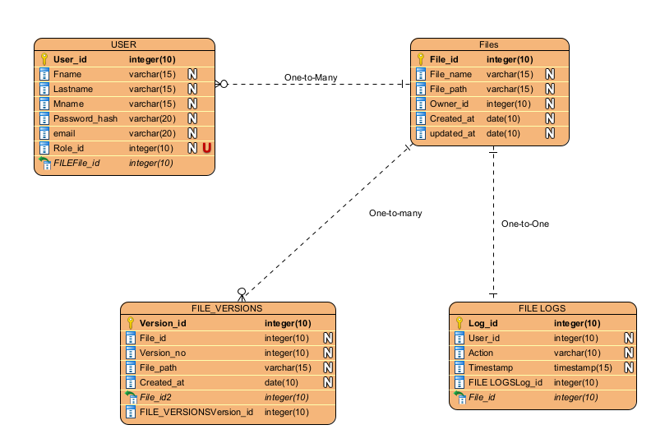

Figure 6: ERD Diagram

# 4.0 CHAPTER FOUR

**SYSTEM IMPLEMENTATION.**

**4.1 Introduction**

In this chapter, we explain in detail how my system was developed to achieve its functionality. It includes the languages that we used to develop the software, the tools and the end result. It also provides a step by step on how a user can use the system once they acquire it. The system is built using flutter flow and the database is connected to firebase.

**4.2 System Architecture**

It defines the structure of the system, how it is organized and how it works. It also defines the end goal of a project. The figure for system architecture is shown in chapter 3.

**4.3 User interface**

This is where the front-end user of a program interacts with the application program through the use of a computer or a phone. Here are some UI developments for my project:

**Home Page**

The homepage provides an intuitive interface with navigation links to modules, a file dashboard displaying recent activities, and quick access to file management, search, and version control features.

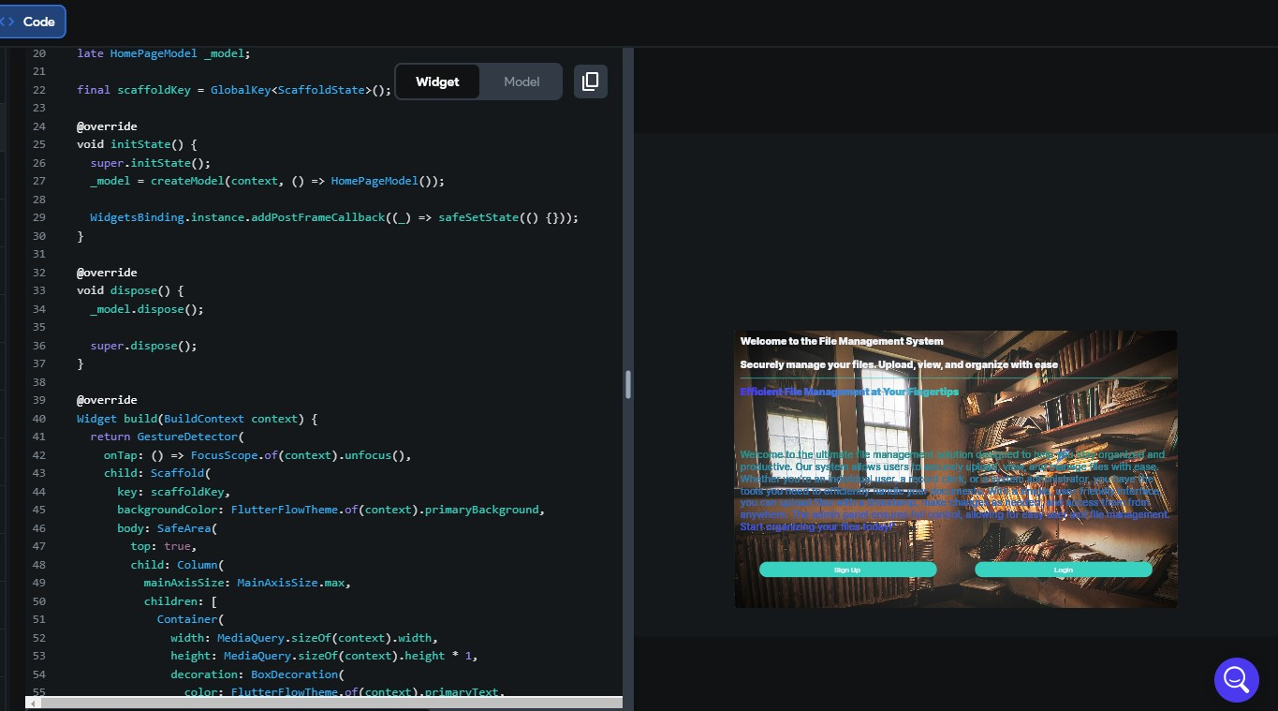

Figure 7: Home page

**Side Navigation**

The side navigation offers a compact menu with categorized links to system modules like File Management, Version Control, Search, Security, Integration, and Settings, ensuring seamless access to functionalities.

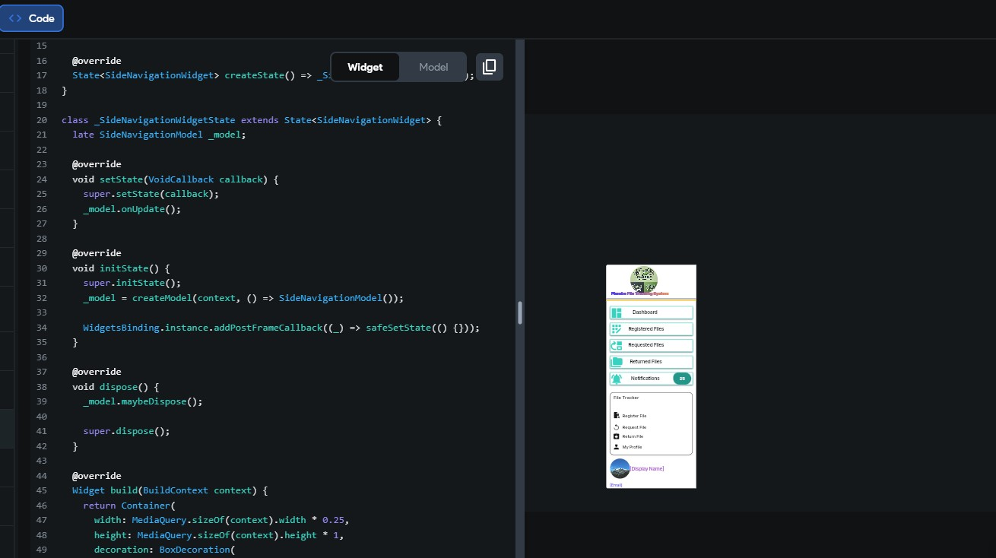

Figure 8: Side Navigation

**File Movement**

The file movement page tracks and displays the transfer history of files, showing details like sender, recipient, timestamps, and current location, with options to initiate or manage file transfers.

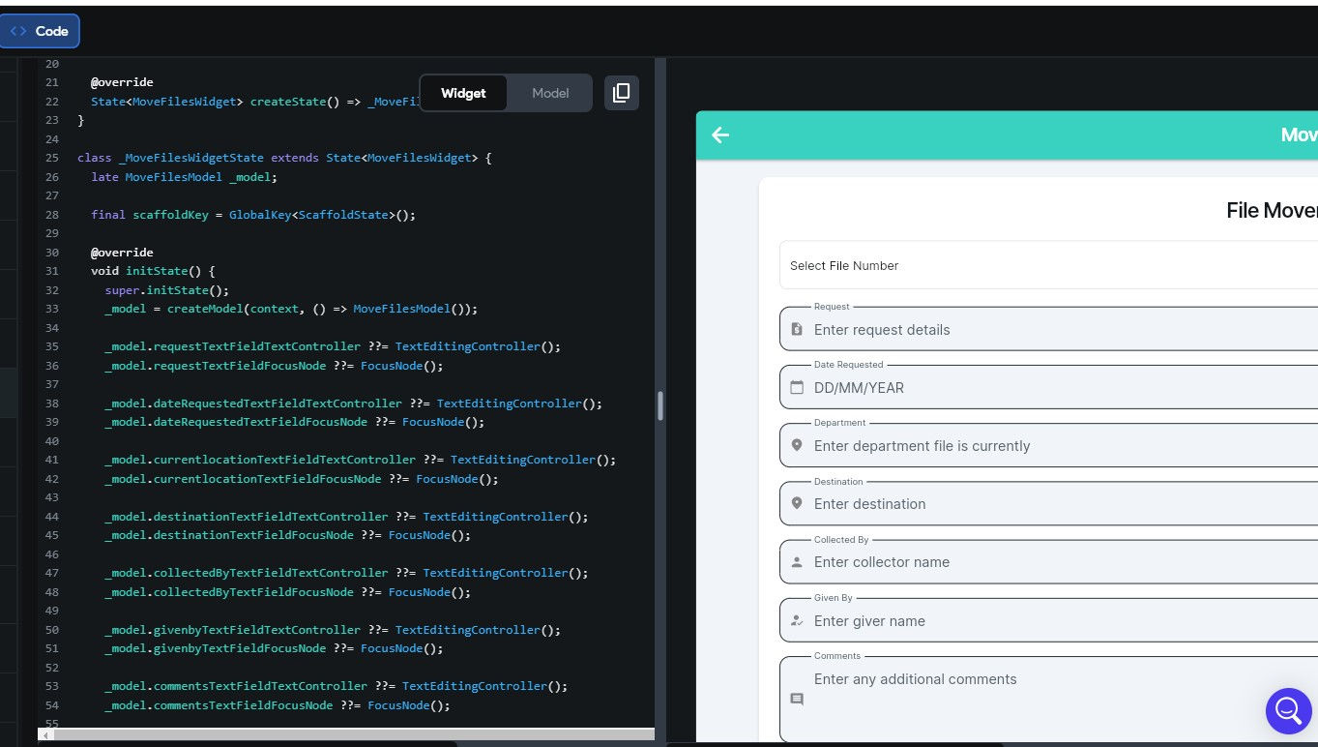

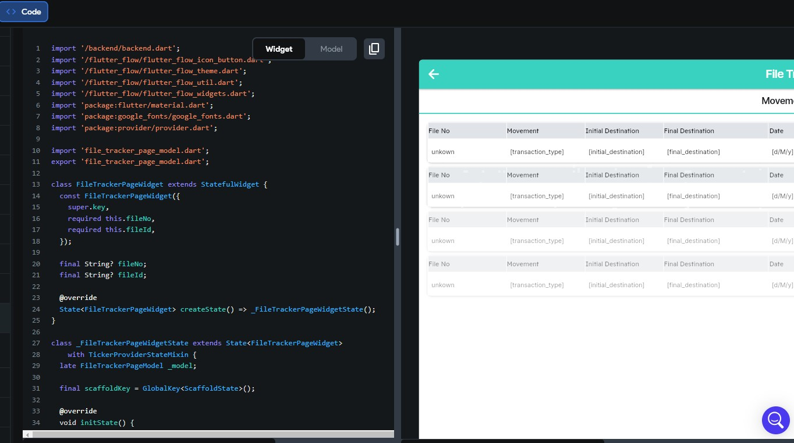

Figure 9: File Movement

LOGIN PAGE

It allows the users to log in to their page

## 

## 

Figure : Login Page

## Admins Page

The page allows the Data manager to register files, see requested files, view returned files and also see notifications. This ensures that the manager is in full control of the system.

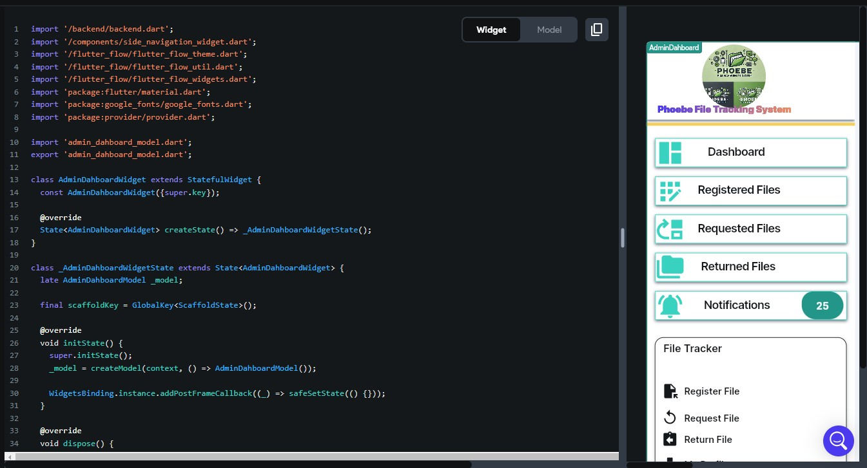

Figure 11: Admins Page

**SYSTEM DATABASE**

This diagrams shows the data that a user enters while signing up and the data should be stored in the firebase authentication part for future logins.

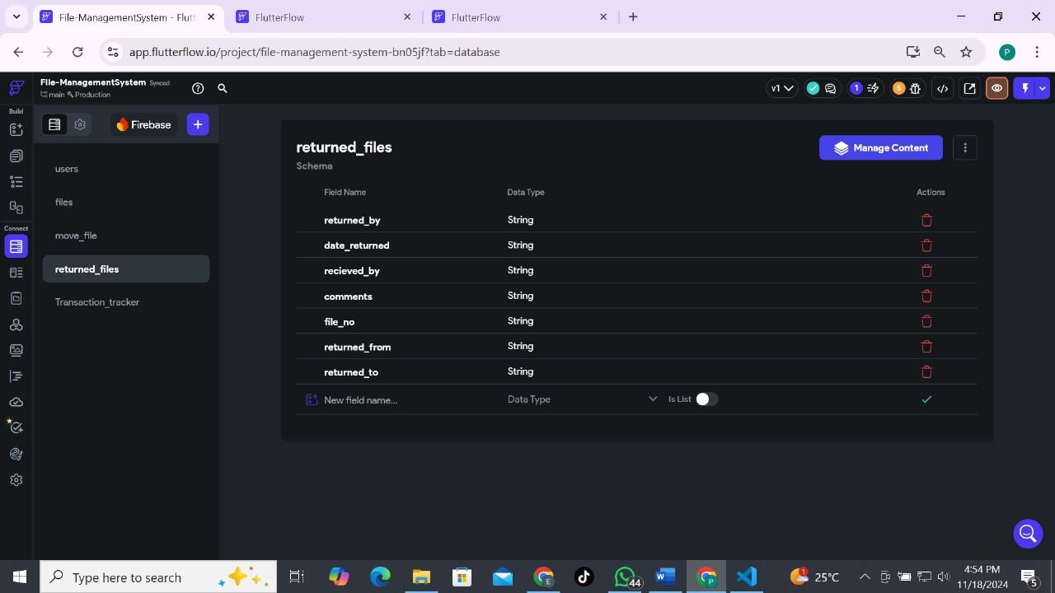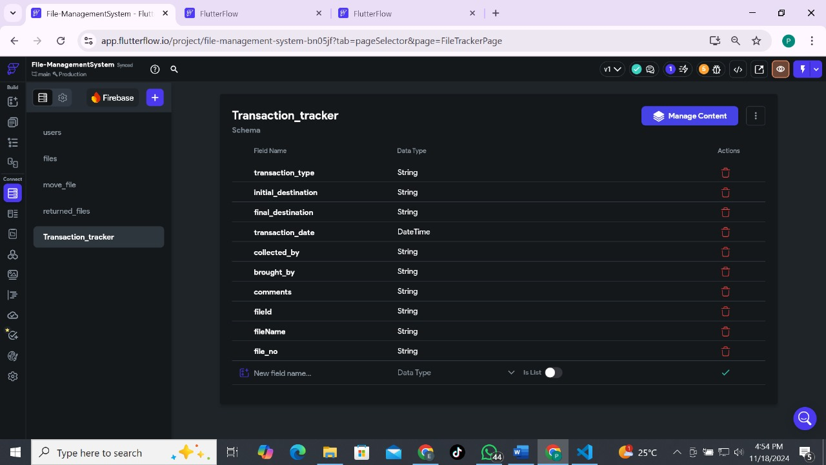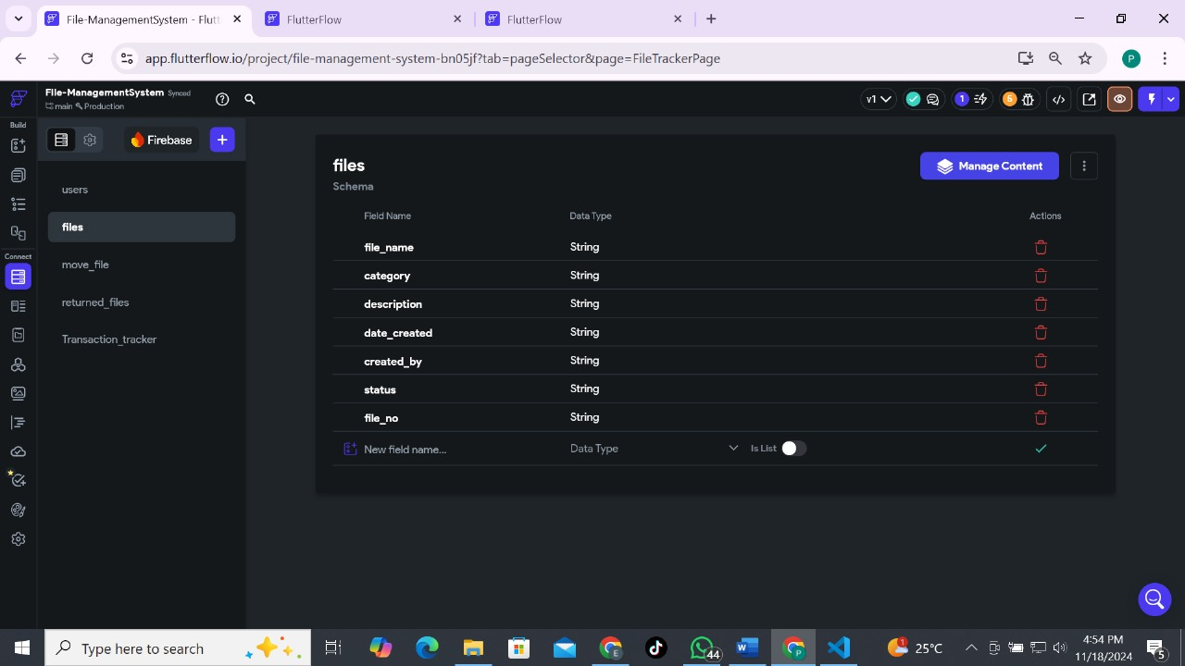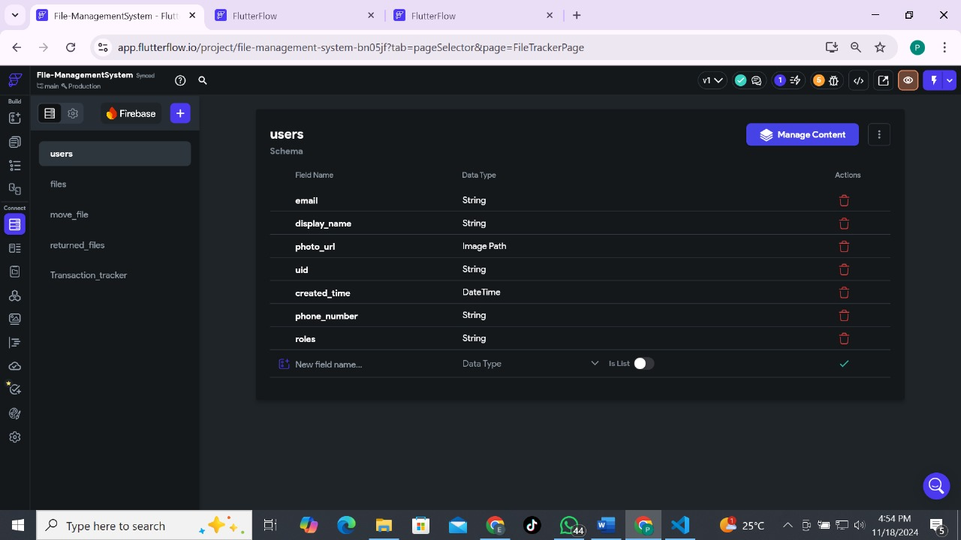

Figure 12: Database

## Recommendations

To enhance the File Management and Tracking System, real-time notifications should be integrated to promptly inform users of file actions or updates. This feature would improve communication and operational efficiency. Additionally, incorporating cloud storage capabilities will allow users to synchronize and back up their files, ensuring flexibility and data reliability.

The system should also support mobile compatibility by introducing a complementary mobile application, enabling users to manage files conveniently from any location. Further, analytics and reporting tools can be added to provide insights into file usage patterns and system performance, facilitating better decision-making. Continuous user training and feedback collection should also be prioritized to ensure the system meets user needs effectively.

## Future Work

Future advancements could include integrating artificial intelligence for predictive search, file categorization, and workflow automation to enhance efficiency. Blockchain technology can be explored for secure, tamper-proof audit trails, particularly for sensitive file transactions. Additionally, integrating with popular collaboration tools such as Slack and Microsoft Teams would enhance team productivity. Expanding multi-language support will make the system accessible to a global audience, while IoT integration can enable physical file tracking to complement digital management. Finally, scalability improvements will ensure the system can handle enterprise-level deployments, supporting large user bases and file volumes seamlessly. These enhancements will position the system for long-term success and adaptability in diverse environments.

## conclusion,

this project aimed to design and develop a comprehensive File Management and Tracking System that addresses the limitations and gaps identified in existing solutions. By incorporating advanced search functionalities, robust security measures, an intuitive user interface, version control, and seamless integration capabilities, our system provides a holistic solution for managing and tracking digital files. This system not only enhances file organization and retrieval efficiency but also ensures real-time tracking and robust security, making it a valuable asset for any organization.

Our detailed analysis of current systems like OpenText, Microsoft SharePoint, bespoke solutions, RFID tracking systems, and other asset tracking technologies highlighted their strengths and weaknesses. By understanding these existing solutions, we have designed a system that mitigates their drawbacks, offering enhanced usability, real-time tracking, and cost-effective scalability. This project bridges the gaps in usability, real-time tracking, and integration, providing a superior file management solution that meets the evolving needs of modern organizations.

With the design and development phases completed, the next crucial step is the system implementation. This phase involves deploying the File Management and Tracking System into the production environment, configuring it to meet specific organizational needs, and ensuring that users are adequately trained to utilize its features effectively. Implementation will ensure that the system is fully operational and integrated into the organization's workflows, marking the transition from development to real-world application and delivering the anticipated benefits to the users.

# 

# References

Brown, J. (2018). Understanding User Needs in Digital File Management. Journal of Information Systems, 45(3), 200-214.

Davis, L. (2017). Usability Testing in System Development. Human-Computer Interaction, 34(2), 155-172.

Doe, J. (2019). Advancements in File Management Systems. International Journal of Technology, 23(4), 180-195.

Smith, W. (2020). The Importance of File Management Systems. Journal of Digital Information, 50(1), 60-78.

White, A. (2018). Developing Secure File Management Systems. Journal of Information Security, 27(3), 110-130.

Dinneen, J. D., & Julien, C. A. (2020). The ubiquitous digital file: A review of file management research. *Journal of the Association for Information Science and Technology*, *71*(1), E1-E32.

Crichton, K. (2023). *Tracking User Web Browsing Behavior: Privacy Harms and Security Benefits* (Doctoral dissertation, Carnegie Mellon University).

Ngenoh, H. (2020). *Livestock management and environmental security in eastern Africa: a case study of Kenya* (Doctoral dissertation, University of Nairobi).

Vegesna, V. V. (2022). Methodologies for Enhancing Data Integrity and Security in Distributed Cloud Computing with Techniques to Implement Security Solutions. *Asian Journal of Applied Science and Technology (AJAST) Volume*, *6*, 167-180.

Bakshi, D.G. (2011), Kerala Govt Nod for Online File Tracking, Alphabet Media, 22 August [Online]. Retrieved from http://www.futuregov.in

Delhi Jal Board., 2010. File Tracking System, eOffice Project Division, National Informatics Centre, CGO Complex, Lodi Road, New Delhi 110003. http://djbfts.nic.in/DJBLive/servlet/opa

Vranopoulos, G. (2022). *Tackling Big Data variety using metadata* (Doctoral dissertation, University of Plymouth).

# APPENDICES

**Appendix 1: Gantt chart**

|  |  |  |  |  |  |  |  |  |  |  |
| --- | --- | --- | --- | --- | --- | --- | --- | --- | --- | --- |
| No | Activity | May 31st | | 1st June – 17th June | | 18th June – 28th June | |  | 29th June – 31st July | |
| 1. | Project proposal approval |  |  |  |  |  |  |  |  |  |
| 2. | Chapter 1 presentation: Introduction |  |  |  |  |  |  |  |  |  |
| 3. | Chapter 2  Presentation: Literature Review |  |  |  |  |  |  |  |  |  |
| 4. | Chapter 3 presentation: Research Design and Methodology |  |  |  |  |  |  |  |  |  |
| 5. | Documentation &  Presentation |  |  |  |  |  |  |  |  |  |

**Appendix 2: Budget**

|  |  |
| --- | --- |
| Item | Cost |
| Internet | Ksh.2000 |
| Printing | Ksh.350 |
| Total | Ksh.2350 |